Annexure :A
TENDER NOTICE No.: KV BSF POKARAN/IT/CONDEMNATION/2020/01
TENDER NOTICE FOR DISPOSAL OF CONDEMNED IT ITEMS

General Terms and Conditions:
1. The Obsolete items have been kept at premises of KV BSF POKARAN. Such of the intending tenders who want to inspect/verify the equipment, should contact the undersigned for details and satisfy themselves about the items they are bidding for.
2. The Quotation letter in a sealed envelope should be addressed to “ The Principal, Kendriya Vidyalaya BSF POKARAN latest by 01.00 PM. on 18/02/2021. The Tender should be super scribed on the top of the sealed envelope as “Tender for Disposal of Condemned items” .
3. Sealed tenders complete in all respect should be sent by By Hand/Speed post/Registered post so as to reach the undersigned on or before the schedule date and time indicated otherwise it will be rejected.
4. Bids received after due date and stipulated date and time due to any reason whatsoever, including postal delays shall not be considered.
5. Only one tender should be kept in one cover. The tender is not transferable. Tender sent by Fax or Email will not be considered.
6. In case the bidder fails to observe and comply with the stipulations made herein or backs out after quoting the rates, the aforesaid amount of earnest money will be forfeited.
7. The items shall be sold to the highest bidder; GST will be extra, as applicable and shall be borne by the bidder only.
8. No items, once deposited to the successful bidder, shall be taken back by KV, on any conditions whatsoever.
9. The bidder should also enclose the certified copy of the an authorization /registration certificate issued by Central Pollution Control Board or any concerned State Pollution Control Board for Recycler/ Re-processor of E waste with the current validity is must to submit with Tender Document as supportive document failing which the Tender will be rejected. The successful tenderer should produce the original certificate before lifting the items from said location.
10. For all purpose of the contract including arbitration there under, the address of the tenderer mentioned in the tender shall be final unless the tenderer notifies the changes of address by a separate letter sent by registered post or speed post to the undersigned. The tenderer shall be solely responsible for the consequences of any omission or error to notify change of address in the aforesaid manner.
11. Each page of the bid document should be signed by the bidder(s). Incomplete and unsigned bids are liable to be rejected.
12. The bidders are required to indicate their PAN Number in their tender since it has been made mandatory by the I.T. Department.
13. The tenderer is at liberty either himself or authorized one representative to be present at the time of opening of the tender. The representative attending the opening of the tender on behalf of the tenderer should bring with him a letter of authority from the tenderer and a proof of identification on the date and time indicated in the “Schedule of Tender”. This event will not be postponed due to non-presence of your representative.
14. The tenderer is required to quote a consolidated price only exclusive GST in Annexure C. The price shall be firm and final. The item wise price will not be acceptable. If tenderer gives item wise price, his tender will summarily be rejected.
15. For financial evaluation, the highest bidder shall be chosen based on the figures quoted in Annexure C.
16. The successful bidder has to make full balance payment in the form of Online Via NEFT/RTGS in Account NAME:- KENDRIYA VIDYALAYA BSF POKARAN VVN, A/C No. – 32719258595 IFSC Code :- SBIN0011306 within 5 days after confirmation, failing which the offer will be cancelled .
17. The successful bidder shall be required to lift all the items from the disposal site to his premises within 5 days after the payment of balance amount. On failure to do so the Principal, KV BSF POKARAN shall have the right to forfeit the entire amount of the bidder and dispose the items to the next highest bidder in such event.
18. The financial bid must be quoted both the figures and words along with GST if any. Any overwriting or erasing the figures shall not be considered for acceptance of the rates offered by the bidder.
19. The cost of dismantling, handling and transportation of the obsolete items from KV BSF POKARAN to the tenderer premises will be the tenderer’s responsibility and all charges for the same will be borne by the tenderer.
20. The personnel employed for shifting the items shall strictly obey the safety rules in force and KV BSF POKARAN will not be responsible for breach of any rules by the personnel of the buyers in any way whatsoever.
21. The condemned e-waste being disposed is only for recycling. The use of the lifted items in any other form will lead to appropriate legal action. The hard drives in the CPUs should be drilled into or crushed beyond usage before lifting. The successful tenderer will be responsible to ensure this action.
22. The successful bidder must provide the recycling certificate to the Principal, after successful recycling /dismantling of the lifted items of the Vidyalaya within the One months after lifting the items.

23. The Principal, KV BSF POKARAN reserves the rights to accept or reject any / all tenders without assigning any reason whatsoever and does not bind himself to accept any specific tender. The decision of The Principal, in this regard is final and binding. Any failure on the part of the tenderer to observe the prescribed procedure and any attempt to canvas will prejudice the tenderer’s quotation. Any attempt on the part of the tenderer to influence in any way for acceptance of his tender will render for rejection.
24. A copy of the Valid E-waste Licenses, PAN No. and Firm Detail will also attach with tender.
-----------------------------xxxxxxxxxxxxxxxxxxxxxx--------------------------

Place: Signature,
Name and address of the Bidder with seal

Date:

Annexure-C
BID DETAILS FOR OBSELETE ITEMS
Name and address of the bidder :
(In Capital letters)

PAN :
GST :
Telephone No. /Mobile no. :
E-mail :
Registration No. With CPCB/SPCB :
Date of issue of Registration :
Validity period of Registration :

I/We have inspected the obsolete items and interested to purchase the same on “As is where is basis”My/ Our offer for the items is given below:
Quote Rs. (In Figure__________________________ (Consolidated Price of All Items)
Rupees (In words) ___________________________________________

I /We gone through the items and conditions given in the bid document and agree with the same. I/We understand that in the event of non – compliance of the terms and conditions of the bid, my bid will be rejected by The Principal, Kendriya Vidyalaya,BSF POKARAN .A copy of the terms and conditions with its all pages signed, in token of acceptance of the same is enclosed.

Signature of Bidder:
Place: Name:
Date: Designation:

Seal

Annexure : D

List of Items to be disposed off

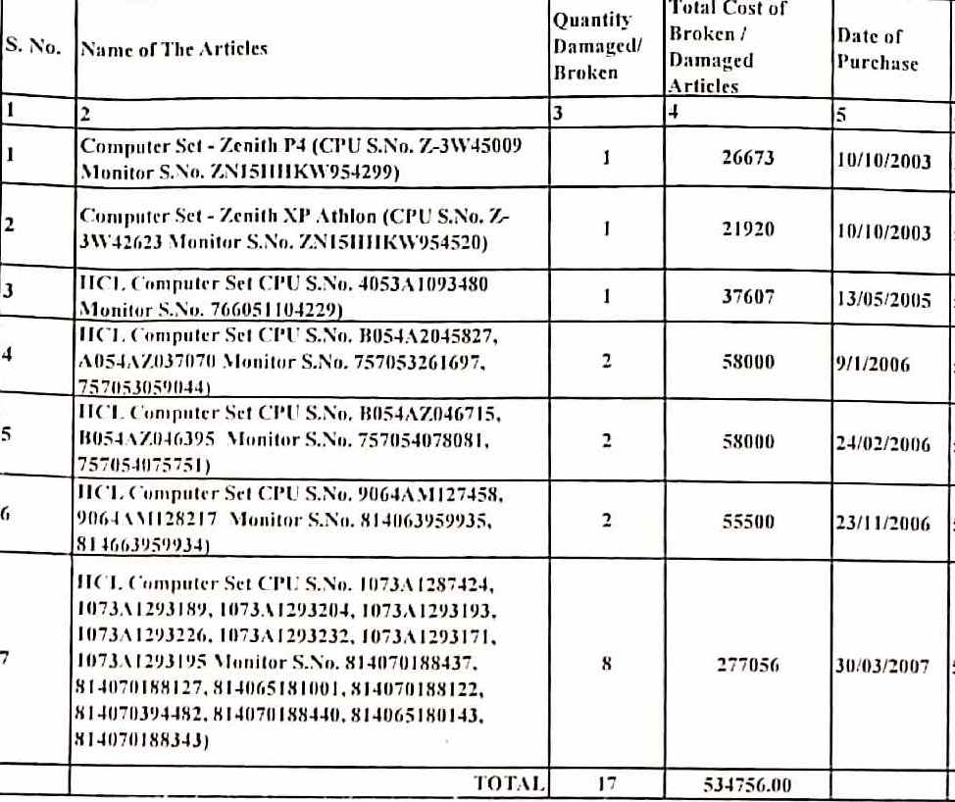

Note: The tenderer is required to quote a consolidated price only in Annexure C. The price
shall be firm and final. The item wise price will not be acceptable. If tenderer gives item wise price, his tender will summarily be rejected.

